Exercise: Advanced Functions
Submit your solutions in the SoftUni judge system at:
https://alpha.judge.softuni.org/contests/advanced-functions-exercise/2765

Sort Array
Write a function that sorts an array with numeric values in ascending or descending order, depending on an argument that is passed to it.
You will receive a numeric array and a string as arguments to the function in your code.
- If the second argument is asc, the array should be sorted in ascending order (smallest values first).
- If it is desc, the array should be sorted in descending order (largest first).

Input
You will receive a numeric array and a string as input parameters.

Output
The output should be the sorted array.

Examples
Input | Output
[14, 7, 17, 6, 8], 'asc' | [6, 7, 8, 14, 17]
[14, 7, 17, 6, 8], 'desc' | [17, 14, 8, 7, 6]

Argument Info
Write a function that displays information about the arguments which are passed to it (type and value) and a summary about the number of each type in the following format:
`{argument type}: {argument value}`
Print each argument description on a new line. At the end print a tally with counts for each type in descending order, each on a new line in the following format:
`{type} = {count}`
If two types have the same count, use order of appearance.
Do NOT print anything for types that do not appear in the list of arguments.

Input
You will receive a series of arguments passed to your function.

Output
Print on the console the type and value of each argument passed into your function.

Example
Input
'cat', 42, function () { console.log('Hello world!'); }
Output
string: cat
number: 42
function: function () { console.log('Hello world!'); }
string = 1
number = 1
function = 1

Fibonacci
Write a JS function that when called, returns the next Fibonacci number, starting at 0, 1. Use a closure to keep the current number.

Input
There will be no input.

Output
The output must be a Fibonacci number and must be returned from the function.

Examples
Sample execution
let fib = getFibonator();
console.log(fib()); // 1
console.log(fib()); // 1
console.log(fib()); // 2
console.log(fib()); // 3
console.log(fib()); // 5
console.log(fib()); // 8
console.log(fib()); // 13

Breakfast Robot
Your task is to write the management software for a breakfast chef robot - it needs to take orders, keep track of available ingredients and output an error if something’s wrong. The cooking instructions have already been installed, so your module needs to plug into the system and only take care of orders and ingredients. And since this is the future and food is printed with nano-particle beams, all ingredients are microelements - protein, carbohydrate, fat, and flavours. The library of recipes includes the following meals:
- apple - made with 1 carbohydrate and 2 flavour
- lemonade - made with 10 carbohydrate and 20 flavour
- burger - made with 5 carbohydrate, 7 fat and 3 flavour
- eggs - made with 5 protein, 1 fat and 1 flavour
- turkey - made with 10 protein, 10 carbohydrate, 10 fat and 10 flavour
The robot receives instructions either to restock the supply, cook a meal, or report statistics. The input consists of one of the following commands:
- restock <microelement> <quantity> - increases the stored quantity of the given microelement
- prepare <recipe> <quantity> - uses the available ingredients to prepare the given meal
- report - returns information about the stored microelements, in the order described below, including zero elements
The robot is equipped with quantum field storage, so it can hold an unlimited quantity of ingredients, but there is no guarantee there will be enough available to prepare a recipe, in which case an error message should be returned. Their availability is checked in the order in which they appear in the recipe, so the error should reflect the first requirement that was not met.
Submit a closure that returns the management function. The management function takes one parameter.

Input
Instructions are passed as a string argument to your management function. It will be called several times per session, so the internal state must be preserved throughout the entire session.

Output
The return value of each operation is one of the following strings:
- Success - when restocking or completing cooking without errors
- Error: not enough <ingredient> in stock - when the robot couldn’t muster enough microelements
- protein={qty} carbohydrate={qty} fat={qty} flavour={qty} - when a report is requested, in a single string

Constraints
- Recipes and ingredients in commands will always have valid names.

Examples
Execution
let manager = solution ();
console.log (manager ("restock flavour 50")); // Success
console.log (manager ("prepare lemonade 4")); // Error: not enough carbohydrate in stock

Input | Output
restock flavour 50  prepare lemonade 4  restock carbohydrate 10  restock flavour 10  prepare apple 1  restock fat 10  prepare burger 1  report | Success  Error: not enough carbohydrate in stock  Success  Success  Success  Success  Success  protein=0 carbohydrate=4 fat=3 flavour=55

Input | Output
prepare turkey 1  restock protein 10  prepare turkey 1  restock carbohydrate 10  prepare turkey 1  restock fat 10  prepare turkey 1  restock flavour 10  prepare turkey 1  report | Error: not enough protein in stock  Success  Error: not enough carbohydrate in stock  Success  Error: not enough fat in stock  Success  Error: not enough flavour in stock  Success  Success  protein=0 carbohydrate=0 fat=0 flavour=0

Functional Sum

Write a function that adds a number passed to it to an internal sum and returns itself with its internal sum set to the new value, so it can be chained functionally.
Hint: Overwrite toString() of the function.
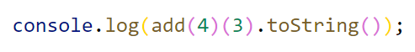

Input
Your function needs to take one numeric argument.

Output
Your function needs to return itself with an updated context.

Example
Input | Output
add(1) | 1
add(1)(6)(-3) | 4

Monkey Patcher *

Your employer placed you in charge of an old forum management project. The client requests new functionality, but the legacy code has high coupling, so you don’t want to change anything, for fear of breaking everything else. You know which values need to be accessed and modified, so it’s time to monkey patch!
Write a program to extend a forum post record with voting functionality. It needs to have the options to upvote, downvote, and tally the total score (positive minus negative votes). Furthermore, to prevent abuse, if a post has more than 50 total votes, the numbers must be obfuscated – the stored values remain the same, but the reported amounts of upvotes and downvotes have a number added to them. This number is 25% of the greater number of votes (positive or negative), rounded up. The actual numbers should not be modified, just the reported amounts.
Every post also has a rating, depending on its score. If positive votes are the overwhelming majority (>66%), the rating is hot. If there is no majority, but the balance is non-negative and the sum of both votes is more than 100, its rating is controversial. If the balance is negative, the rating becomes unpopular. If the post has less than 10 total votes, or no other rating is met, its rating is new regardless of balance. These calculations are performed on the actual numbers.
Your function will be invoked with the call(object, arguments), so treat it as though it is internal for the object. A forum post, to which the function will be attached, has the following structure:
JavaScript
{
id: <id>,
author: <author name>,
content: <text>,
upvotes: <number>,
downvotes: <number>
}
The arguments will be one of the following strings:
- upvote – increase the positive votes by one
- downvote – increase the negative votes by one
- score – report positive and negative votes, balance and rating in an array; obfuscation rules apply

Input
Input will be passed as arguments to your function through a call() invocation.

Output
Output from the report command should be returned as a result of the function in the form of an array of three numbers and a string, as described above.

Examples
Sample execution
let post = {
id: '3',
author: 'emil',
content: 'wazaaaaa',
upvotes: 100,
downvotes: 100
};
solution.call(post, 'upvote');
solution.call(post, 'downvote');
let score = solution.call(post, 'score'); // [127, 127, 0, 'controversial']
solution.call(post, 'downvote'); // (executed 50 times)
score = solution.call(post, 'score'); // [139, 189, -50, 'unpopular']
Explanation
The post begins at 100/100, we add one upvote and one downvote, bringing it to 101/101. The reported score is inflated by 25% of the greater value, rounded up (26). The balance is 0, and at least one of the numbers is greater than 100, so we return an array with the rating 'controversial'.
We downvote 50 times, bringing the score to 101/151, the reported values are inflated by 151*0.25=38 (rounded up), and since the balance is negative with return an array with rating 'unpopular'.

DOM-Related Problems
The following problems must be solved using DOM manipulation techniques.
Environment Specifics
Please, be aware that every JS environment may behave differently when executing code. Certain things that work in the browser are not supported in Node.js, which is the environment used by Judge.
The following actions are NOT supported:
- .forEach() with NodeList (returned by querySelector() and querySelectorAll())
- .forEach() with HTMLCollection (returned by getElementsByClassName() and element.children)
- Using the spread-operator (...) to convert a NodeList into an array
- append() in Judge (use only appendChild())
- prepend()
- replaceWith()
- replaceAll()
- closest()
- replaceChildren()
- Always turn the collection into a JS array (forEach, forOf, et.)
If you want to perform these operations, you may use Array.from() to first convert the collection into an array.

Simple Calculator

Create a function calculator which returns an object that can modify the DOM. The returned object should support the following functionality:
- init (selector1, selector2, resultSelector) - initializes the object to work with the elements corresponding to the supplied selectors.
- add () - adds the numerical value of the element corresponding to selector1 to the numerical value of the element corresponding to selector2 and then writes the result in the element corresponding to resultSelector.
- subtract () - subtracts the numerical value of the element corresponding to selector1 from the numerical value of the element corresponding to selector2 and then writes the result in the element corresponding to resultSelector.

Input
There will be no input your function must only provide an object.

Output
Your function should return an object that meets the specified requirements.

Constraints
- All commands will always be valid, there will be no nonexistent or incorrect input.
- All selectors will point to single textbox elements.
- Use the given skeleton to solve this problem.

Sample execution
const calculate = calculator ();
calculate.init ('#num1', '#num2', '#result');

Next Article
Write a JS program that sequentially displays articles on a web page when the user clicks a button. You will receive an array of strings that will initialize the program. You need to return a function that keeps the initial array in its closure and every time it’s called, it takes the first element from the array and displays it on the web page, inside "article", in div with ID "content". If there are no more elements left, your function should do nothing.
Your function will be called automatically, there is no need to attach any event listeners.

Input
You will receive an array of strings.

Output
Return a function that sequentially displays the array elements on the web page.

Examples
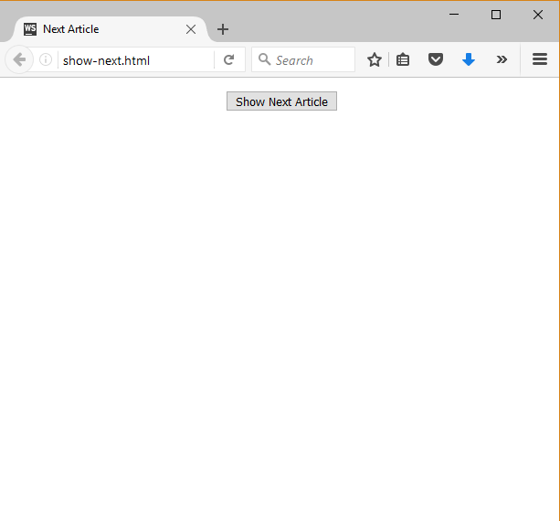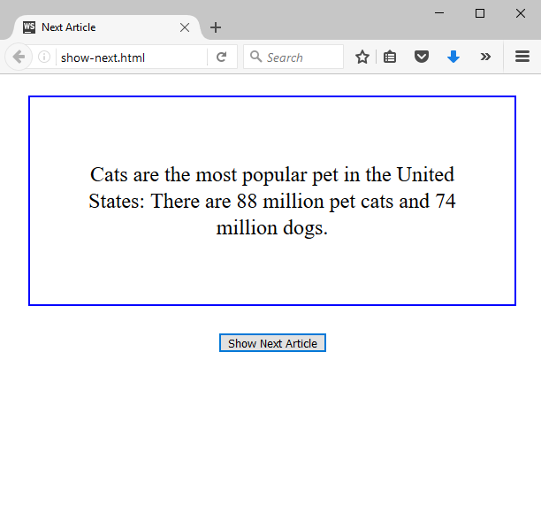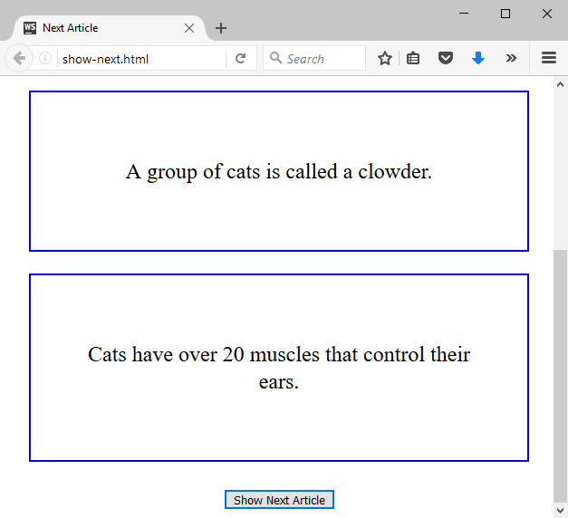

Task Manager
Use the index.html and app.js files to solve this problem. You have NO permission to directly change the given HTML code (index.html file).
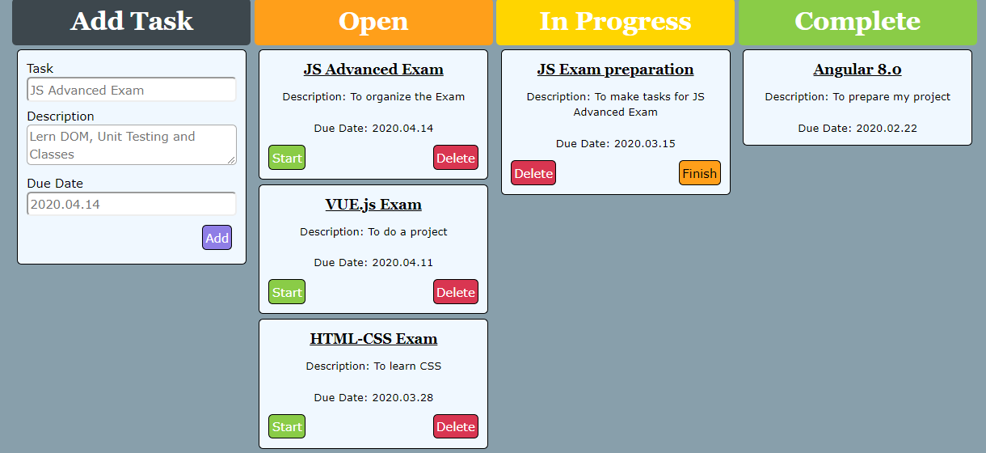

Your task
Write the missing JavaScript code to make the Task Manager Functionality works as follows:
When the [Add] button is clicked, first you need to validate the inputs. If any of the input fields are empty, the function doesn’t make anything.
After validating the input fields, you need to add the new task (article) in the "Open" section.
The HTML structure looks like this:
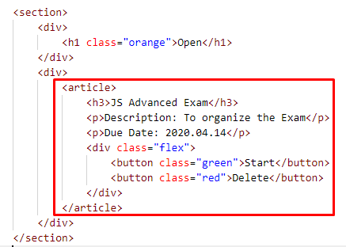
The article should have two buttons "Start" and "Delete". Be careful to set the classes for the buttons and the parent-div.
When the [Start] button is clicked, you need to move the Task in the section "In Progress". Be careful with the buttons! The HTML structure looks like this:
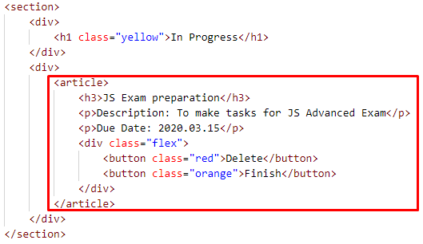
When the [Delete] button is clicked, the Task (whole article) should be removed from the HTML.
After clicking the [Finish] button, the Task will be completed, and you should move the article to the section "Complete". The buttons with their parent div-element should be removed.
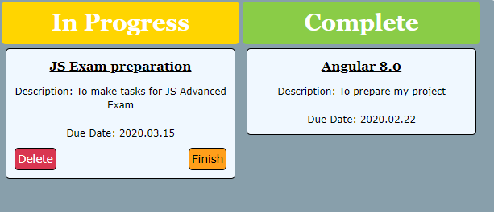
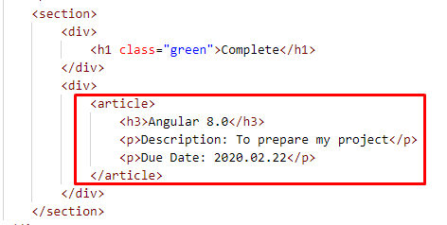

Central Cinema *
Use the given skeleton to solve this problem.
Note: You have NO permission to change directly the given HTML (index.html file).
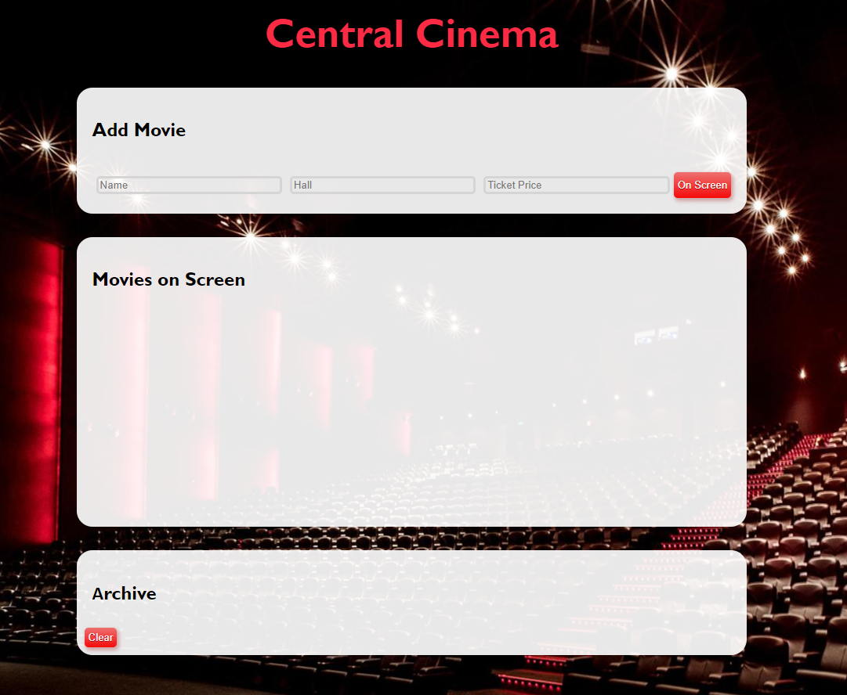

Your Task
Write the missing JavaScript code to make the Central Cinema application work as expected.
Each movie has a Name, Hall and Ticket Price.
When you click the [On Screen] button and only if inputs are all filled and the ticket price value is a number, then a new list item should be added to the Movies on Screen section. Clear the inputs.

The new item should have the following structure:
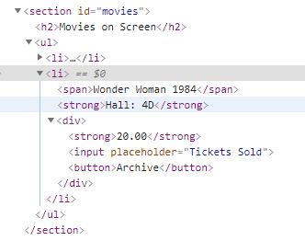
You should create a li element that contains a span element with the name of the movie, a strong element with the name of the hall like: `Hall: ${hallName}`, and a div element. Inside the div element, there is a strong element with the ticket price (fixed to the second digit after the decimal point), an input element with a placeholder containing: "Tickets Sold" and a button [Archive].
When you click the [Archive] button and only if the input for tickets count is filled with a number like:
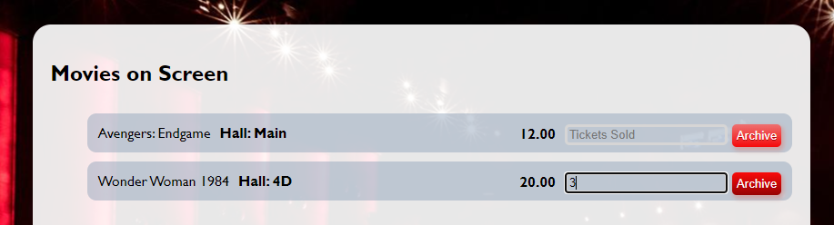
You should add that item to the Archive section like a list item in the ul, calculating the total profit of the movie like this:

Use the following format:
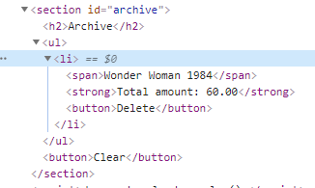
Here we have a list item containing span element with the name of the movie, strong element with total profit like: `Total amount: ${total price}`, fixed to the second digit after the decimal point. Add a delete button [Delete].
When you click the [Delete] button, you should delete the current list item.
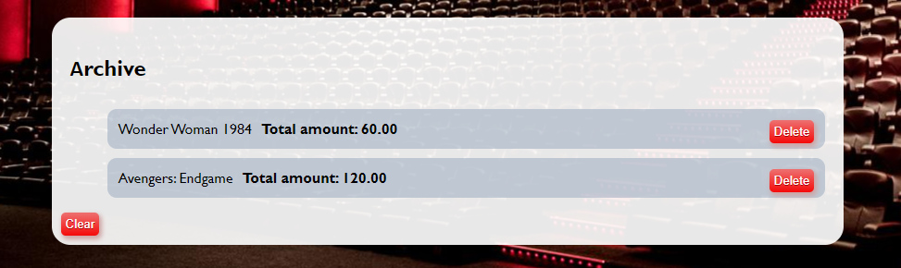

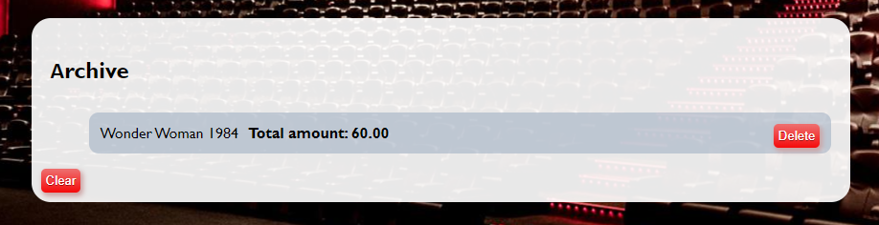
Finally, when we click the [Clear] button delete all li elements from the archive section. No matter how many archived movies we have the archive section leaves like this:


